
Teacher’s Getting Started

Purpose: This guide provides the steps for teachers to get started in AET as well as getting students started! Use this as a reference while accessing the system for the first time.

Step 1: Sign In to your Account
- Go to cte.theaet.com/ and us Google Authentication to access your account
- Go to cte.theaet.com/. Click "Login” button in the top-right corner and enter your (1) Email and (2) password that you have been assigned
- If you cannot get access, reach out to your school administration to be sure you are setup as a teacher in your school.

Step 2: Completing your AET Teacher PROFILE- Just like students, teachers must start their AET account in the PROFILE tab. Try to complete all steps of the PROFILE before moving onto other tabs of AET. Some key items to be completed are:

- Update your teacher information - this should be reviewed every school year to ensure the correct teachers are listed as well as their contact information.
- Setup Courses that are Taught- Each student needs to enroll in course you have so that you can view students in your class; To add a course:
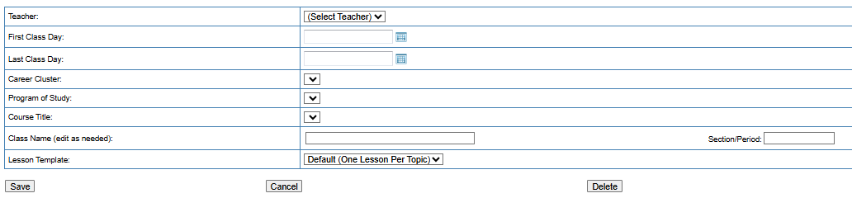
a. Under the PROFILE tab, click the "Course Builder" link to add courses offered in your Ag Program.
  - Click “New Course”
  - Enter course details:
  - Hit “Save”


Step 3: Add Student Accounts (ACCOUNTS tab) – In order for students to access AET, create accounts:

  - Select the ACCOUNTS tab from the top menu (Help video icons to assist!).
  - Select “Manage All Accounts” to see a list of all your active student accounts.
  - To Add Student Accounts, click either “one” or “multiple”…best approach:
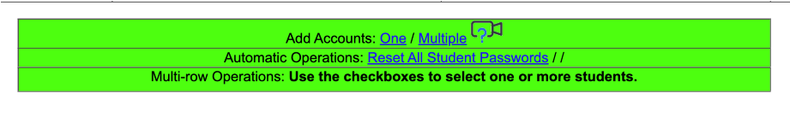
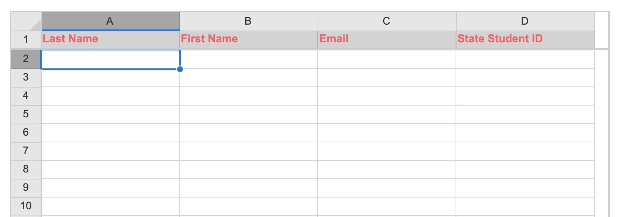
  - Choose “Multiple.” To add in a group of students (i.e. your class)
  - Using the “spreadsheet approach” you can use your LMS/student list to copy and paste key student data to begin (Name / email / State ID#
used in reporting)
  - Choose “save” and review student results and make correction in each cell as needed.
  - Choose “Add” to populate your student list…some Tips!
    - Use a school email and essential if connected to Google to assist in logins
    - If students are logging in with their informations….
      - Usernames = first initial and last name with the first two letters capitalized. (Example: VKirby)
      - The username and password are both case sensitive

Once student accounts have been successfully added, have students review the PROFILE Checklist Worksheet for students to get them started!
Questions? Info@TheAET.com 1

